# Link to Backlog

[https://trello.com/b/wZUu5hMY/camp-project-2014#](https://trello.com/b/wZUu5hMY/camp-project-2014)

# Setup Development Environment

* Install JDK 7 (NOT JDK 8[1])   
  <http://www.oracle.com/technetwork/java/javase/downloads/index.html>
* Install Scala  
  <http://www.scala-lang.org/download/>
* Gradle
  + Download from <http://www.gradle.org/downloads>
  + Define Windows Variable GRADLE_HOME, e.g. C:\dev\tools\gradle-1.11
  + Add %GRADLE_HOME%\bin to %PATH%  
    Tip: Use <http://www.rapidee.com/en/download>
* Install Netbeans   
  <https://netbeans.org/downloads/index.html>
* Install „Eclipse IDE for Java EE Developers”  
  <https://www.eclipse.org/downloads/>
* Adjust eclipse.ini   
  <http://wiki.eclipse.org/FAQ_How_do_I_increase_the_heap_size_available_to_Eclipse%3F>  
  -vmargs  
  -Xms512m  
  -Xmx2048m  
  -XX:+UseParallelGC  
  -XX:PermSize=256M  
  -XX:MaxPermSize=512M
* Eclipse Plugins installieren (Marketplace)  
    
    
    
  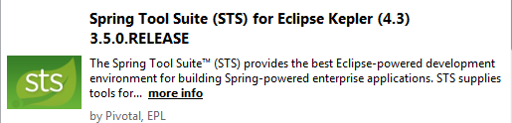  
  siehe <http://www.gradle.org/tooling> [2]  
    
  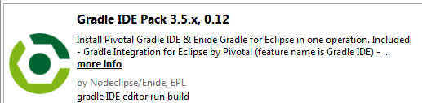
* Install Gradle Extension (see <https://github.com/spring-projects/eclipse-integration-gradle/blob/master/README.md> ):
  + Open eclipse
  + Help 🡪 Dashboard
  + 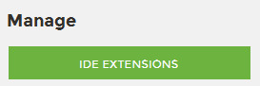
  + 
  + Install

1. due to problems with gradle/scala, see <http://forums.gradle.org/gradle/topics/enable_to_setup_a_simple_scala_build>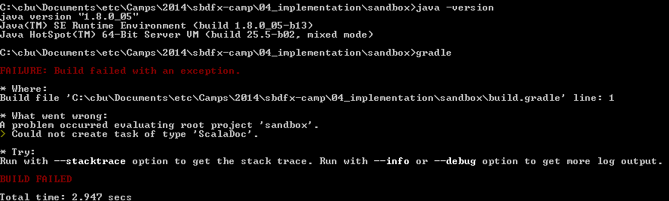
2. (noch) nicht klar, ob benötigt:  
     
   🡪 macht probleme 🡪 nicht installieren